**Process technology**

* 1. **What is process technology and why is it getting more important?**

**Process technology versus product technology**

**Technology** = the use of scientific knowledge for real-world purposes

**Product technology** = embodied in a products hardware and software

**Process technology** = machines, equipment and devices that create and/or deliver products and services. Has a very significant effect on quality, speed, dependability, flexibility and cost

Technology can play a key role in facilitating the direct transformation of inputs to an operation

**Indirect process technology** = the IT that runs planning and control activities can be used to help managers and operators control and improve their processes

**Direct process technology** = acts on material, information and customers

**What is new in new technologies?**

Most new process technologies have a greater capability than what they are replacing – they are capable of doing things that older technologies could not do or do as well

Increased capabilities have a greater scope of application and can be used in sectors of the economy and in types of operation where process technology used to be far less important

**New technologies often have increased capabilities**

Technologies are becoming cheaper, more proficient and more adaptable with algorithms that can outperform human decision-making. Over a 20-year period the cost of industrial robots has dropped by half while the cost of labor has risen over 100%

**Moravec’s paradox**

**Moravec’s paradox** = the enigma of AI struggling with tasks that most humans find easy. It is comparatively easy to make computers exhibit adult-level performance but difficult to give them the skills in tasks that require perception and mobility skills.

**How do we view new technologies?**

It is difficult to separate the reality of a new technology from the publicity and speculation that surrounds it, especially when its potential is not yet fully understood.

**Gartner Hype Cycle** = how perceptions of a technology’s usefulness develop over time:

1. **Technology trigger** = the early stages of a technology, probably exists in a theoretical or prototype stage but there are no working practical demonstrations
2. **Peak of inflated expectations** = technology has developed to a point where it is implemented by some more adventurous early adopter operations. There is press coverage describing both successful and unsuccessful experiences
3. **Through of disillusionment** = the difficulties of using the technology in practical situations start to demonstrate its shortcomings. Results in a backlash leading to disappointment and disillusionment with the technology
4. **Slope of enlightenment** = problems with the technology are slowly solved and its potential becomes more realistically understood. It is adopted by an increasing number of operations that learn how to implement it in their context
5. **Plateau of productivity** = the technology in its developed form becomes widely adopted, probably with technical standards being shared by users and suppliers

**Process technology and transformed resources**

Different types of process technology can be distinguished by what the technology actually processes (materials, information or customers)

**Material-processing technologies** = includes any technology that shapes, transports, stores or changes physical objects. Includes the machines and equipment in manufacturing operations, trucks, packing machines etc

**Information-processing technology** = includes any device that collects, manipulates, stores or distributes information

**Customer-processing technology** = there are 3 types:

1. **Active interaction technology** = customers are using the technology to create the service. vehicles, online shopping, self-checkout stations.
2. **Passive interactive technology** = process customer in some way but does not expect the customer to take a direct part in the interaction. Aircraft, mass transport systems, elevators
3. **Hidden technology** = customers are not aware of them, tracks customers movements or transactions. Security monitoring, face-recognition

**Integrating technologies** = processes more than one type of resource and/or are combinations of other technologies. Electronic point of sale, Industry 4.0

**How should operations managers manage process technology?**

There are 3 things operations managers must do to choose process technology:

1. **Understand the technology** to the extent that they are able to articulate what it should be able to do
2. **Evaluate alternative technologies** since they affect the operations they manage and share in the decisions of which technology to choose
3. **Develop, plan and implement** the technology so it can reach its full potential in contributing to the performance of the operation
   1. **How can one understand the potential of new process technology?**

Understanding process technology means knowing enough about the principles behind the technology to be comfortable in evaluating some technical information, capable of dealing with experts in the technology and confident enough to ask relevant questions

**The four key questions**

Operations managers grasp the essentials of the technology by these questions:

1. What does the technology do that is different from other similar technologies?
2. How does it do it? What particular characteristics of the technology are used to perform its function?
3. What benefits does using the technology give to the operation?
4. What constraints or risks does using the technology place on the operation?

**Emerging technologies – understand their primary capabilities**

**Classifying technologies by their primary capabilities**

**Primary capability** = what a technology actually does better than the technology it replaces. There are 5 primary capabilities:

1. Technologies that can **think or reason** (Artificial Intelligence)
2. Technologies that can **see or sense** (augmented and virtual reality, sensors)
3. Technologies that can **communicate or connect** (cloud computing, blockchain, RFID technologies)
4. Technologies that can **move physical objects** (Robots, automated guided vehicle)
5. Technologies that can **process materials** (3D printing)

**Industry 4.0**

**Industry 4.**0 = Combines several primary capabilities, comprises smart machines, storage systems and production facilities capable of autonomously exchanging information, triggering actions and controlling each other independently

* 1. **How can new process technologies be evaluated?**

**Technological risks** = security, obsolescence, implementation problems and the tendency of some organizations to get carried away with new technology for its own sake.

3 criterias for evaluating whether to adopt an alternative technology to whatever is being used are:

1. Does the technology fit the volume-variety characteristics of the task for which it is intended?
2. What aspects of the operation’s performance does the technology improve?
3. Does the technology give an acceptable financial return?

**Does the process technology fit the volume-variety characteristics of the task?**

Different process technologies are appropriate for different types of operations since they both process different transformed resources and do it at different levels of volume and variety.

**General purpose technology** = performs a wide range of processing activities that high variety demands, required for high-variety with low-volume processes

High-volume-low-variety processes uses technology that is more dedicated to its narrower range of processing requirements

The 3 dimensions that vary with volume and variety are:

1. **Degree of automation**
   1. **Capital intensity of process technology** = ratio of technological to human effort employed
   2. High-variety with low volume has lower automation compared to those with higher volume and lower variety
2. **Scale or scalability** = capacity of the technology to process work, ability to shift to a different level of useful capacity quickly and cost-effectively
   1. **Large-scale technologies** can process items more cheaply than small-scale technologies. They need high volume and can only cope with low variety
   2. **Small-scale technologies** are flexible and robust, suited for high-variety with lower volume
3. **Degree of coupling or connectivity** = extent to which it is integrated with other technologies, linking together separate activities within a single piece of process technology
   1. **Tight coupling** gives fast process throughput an means that flow is simple and predictable, thus easier to keep track of parts when they pass through fewer stages
   2. **Closely coupling** = can be expensive (each connection requires capital cost) and vulnerable (a failure in one part of the system can affect the whole system)
   3. More suited to low variety and high volume

**How does the technology improve the operation’s performance?**

Since some process technologies can perform novel tasks the criterion “quality” is split into **specification quality** (what the technology can do) and **conformance quality** (can it do it in an error-free manner). The criterion “flexibility” is split into **response flexibility** (how easy is it to switch between tasks) and **range flexibility** (how many different tasks can it perform)

Assessment questions for the criteria are:

* **What** can the technology do?
* **How well** can the technology do things?
* **How fast** can the technology do things?
* **How reliably** can the technology do things?
* **How flexibly** can the technology do things?
* **What range** of things can the technology do?
* **How sustainable** is the technology?
* **Where** can the technology do it?
* **How safely** can the technology do it?
* **How connectedly** can the technology do it?
* **How securely** can the technology do it?

Evaluations in the polar representation are classed as **worse than** (red), **about the same** (orange) and **better than** (green) compared to what the technology is replacing

**Does the technology give an acceptable financial return?**

The time value of money must be considered since the costs associated with investing in the technology occurs up front, even though the benefits of investing in new technology can be spread over many years.

The present value of **money x** in **n years** time at a discount rate of **r** percent is

* 1. **How are new process technologies developed and implemented?**

Developing and implementing process technology means organizing all the activities involved in making the technology work as intended

Implementation depends on its specific nature, the changes implied by the technology and the organizational conditions that apply during its implementation

**Technology planning in the long term – technology roadmapping**

**Technology roadmap TRM** = an approach that provides a structure that coordinates the consultation operations managers make with other parts of the firm regarding the formal planning process. It is a process that supports technology development by facilitating collaboration between the various activities that contribute to technology strategy

Allows technology managers to define their firm’s technological evolution in advance by planning the timing and relationships between the various elements that are involved in technology planning

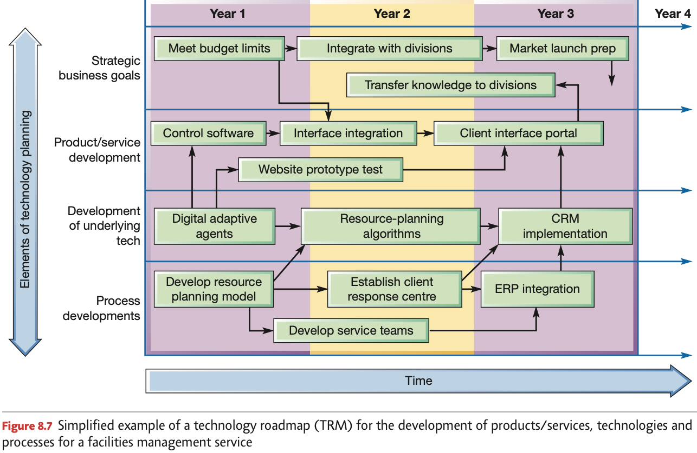

**Resource and process distance**

The degree of difficulty in the implementation of process technology depends on the degree of novelty of the new technology resources and the changes required in the operation’s processes.

The less that the new technology resources are understood the greater their distance from the current technology resource base of the operation

The extent to which an implementation requires an operation to modify its existing processes, the greater the **process distance**. Distance makes it difficult to adopt a systematic approach to analyzing change and learning from mistakes.

Implementations that involve little **process or** **resource distance** provide an ideal opportunity for organizational learning

An implementation where the resource and process distance means that everything is up for grabs makes it difficult to know what has worked and what has not

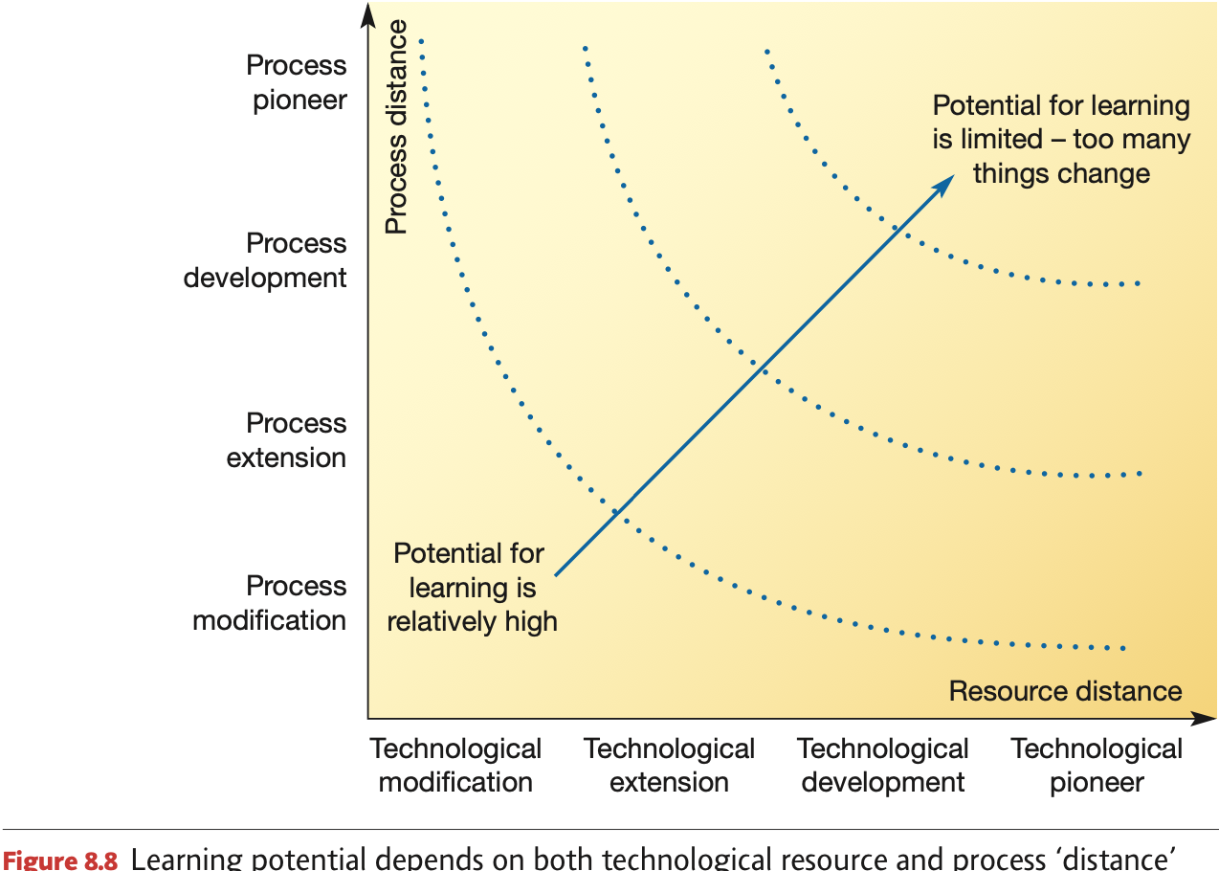

**Customer acceptability**

If customers are to have direct contact with technology they must have some idea of how to operate it. Where customers have an active interaction with technology, the limitations of their understanding of the technology can be the main constraint on its use

The ability of the operation to train its customers in the use of its technology depends on 3 factors

1. **Complexity** of tasks performed by the customer
   1. **Complex services** require **higher levels of training**
2. **Repetition** of tasks performed by the customer
   1. **Payback for the investment in training** is greater if the customer uses the technology frequently, helps reinforce the training with regular repetition if customer were to forget how to use it
3. **Variety** of tasks performed by the customer
   1. **Lower variety** makes it easier to use

**Anticipating implementation problems**

Implementation of any process technology must account for the adjustment issues that always occur when making organizational change

**Adjustment issues** = losses that could be incurred before the improvement is functioning as intended

**Murphy’s law** = if anything can go wrong it will

Adjustment costs stem from unforeseen mismatches between the new technology’s capabilities and needs and the existing operation

